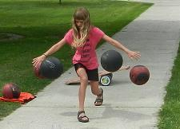
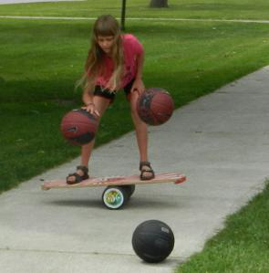
Marika Luneau (10) dribbling 2-4 basketballs.
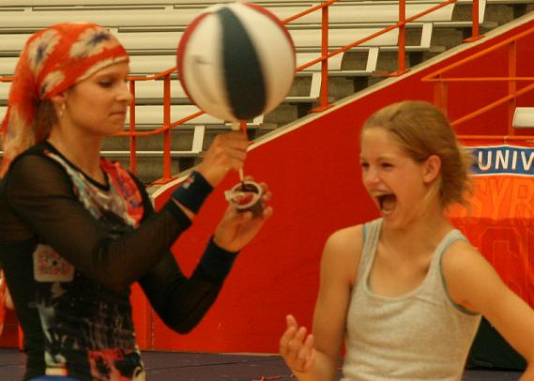 A volunteer eating a pudding the fun way!
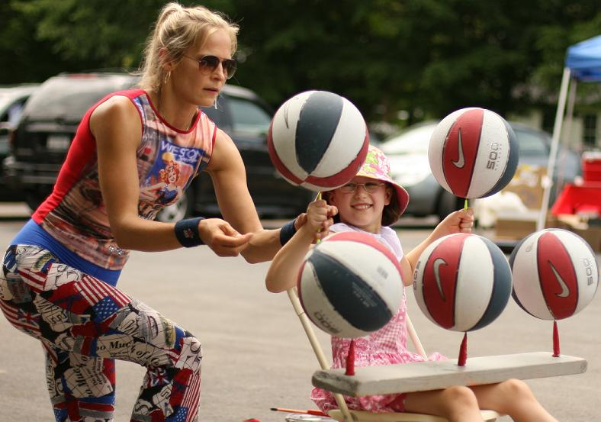 A volunteer spinning 5 basketballs
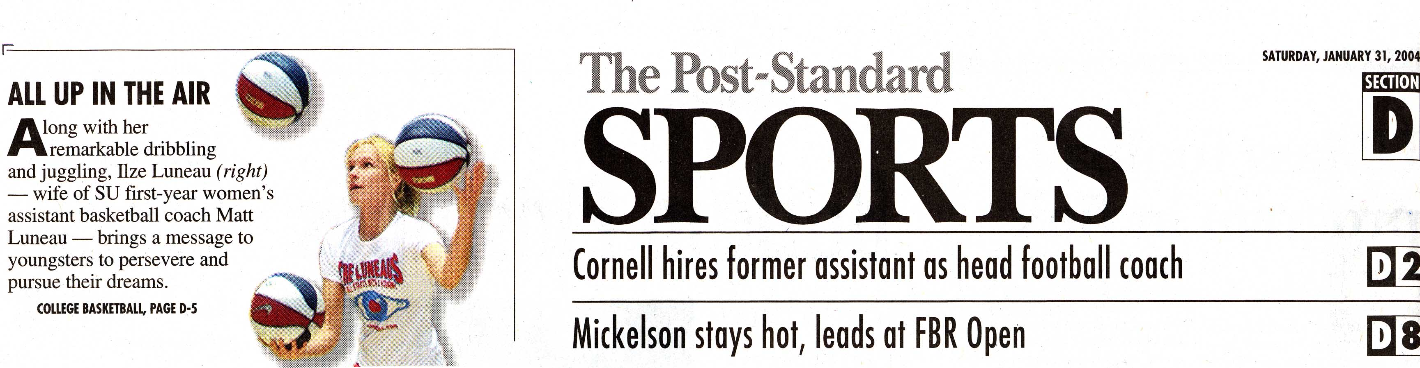
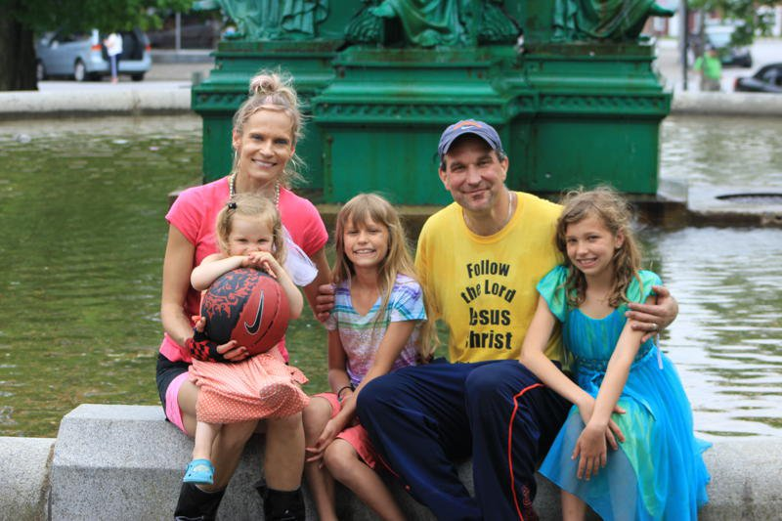
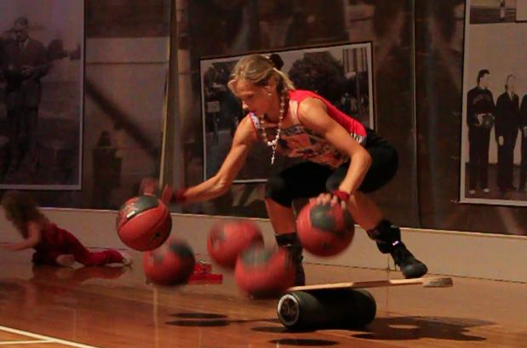
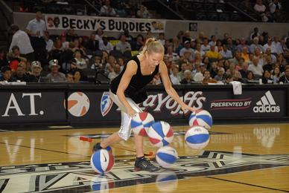
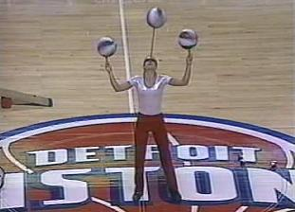
www.BasketballFamily.com
The Luneaus BASKETBALL FAMILY

”It All Starts With A Vision!”
Basketball Motivational and Entertainment PRESENTATIONS
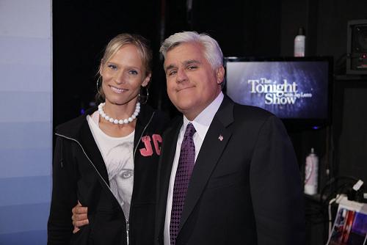
School Assemblies, Basketball Camps, Half-Time Shows, Summer Camps, Charity Events, Company Functions, Private Parties, Private and Group Lessons.
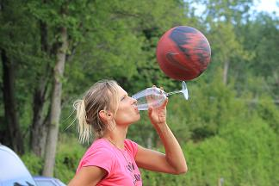
www.BasketballFamily.com
MOTIVATIONAL MESSAGE - CHARACTER EDUCATION
Great motivational message on self esteem and family values delivered through entertaining and fascinating basketball ballhandling routine. Children's and adults' attention will be captured with amazing 3-6 basketball dribbling, juggling and spinning tricks to deliver important message on setting goals, working hard, never giving up, and respecting others.
Have a Dream, Learn to Set Goals – “It All Starts With A Vision!” Work Hard to Achieve Your Goals Have Fun While Working Hard Never Give Up – Believe in Yourself Lead a Balanced Life – Respect and Help others Make Good Decisions - Don’t Use Drugs and Alcohol
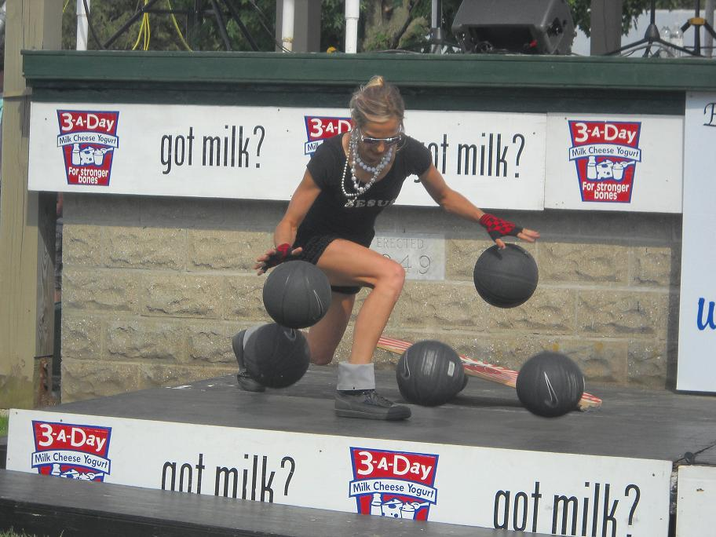
(No religious or spiritual messages at secular schools, unless requested)

THE SHOW
Ilze dribbles and juggles three, four, five and six basketballs on a balance board and using other props to music and dance. Spinning tricks with one, two, and three balls. When available, Marika (10) dribbles 2-4 basketballs on indo board, Evangelica (4) dribbles 2 basketballs, and Iliana (11) sings.
Matt Luneau will participate when available with fire and knife juggling and balancing tricks.
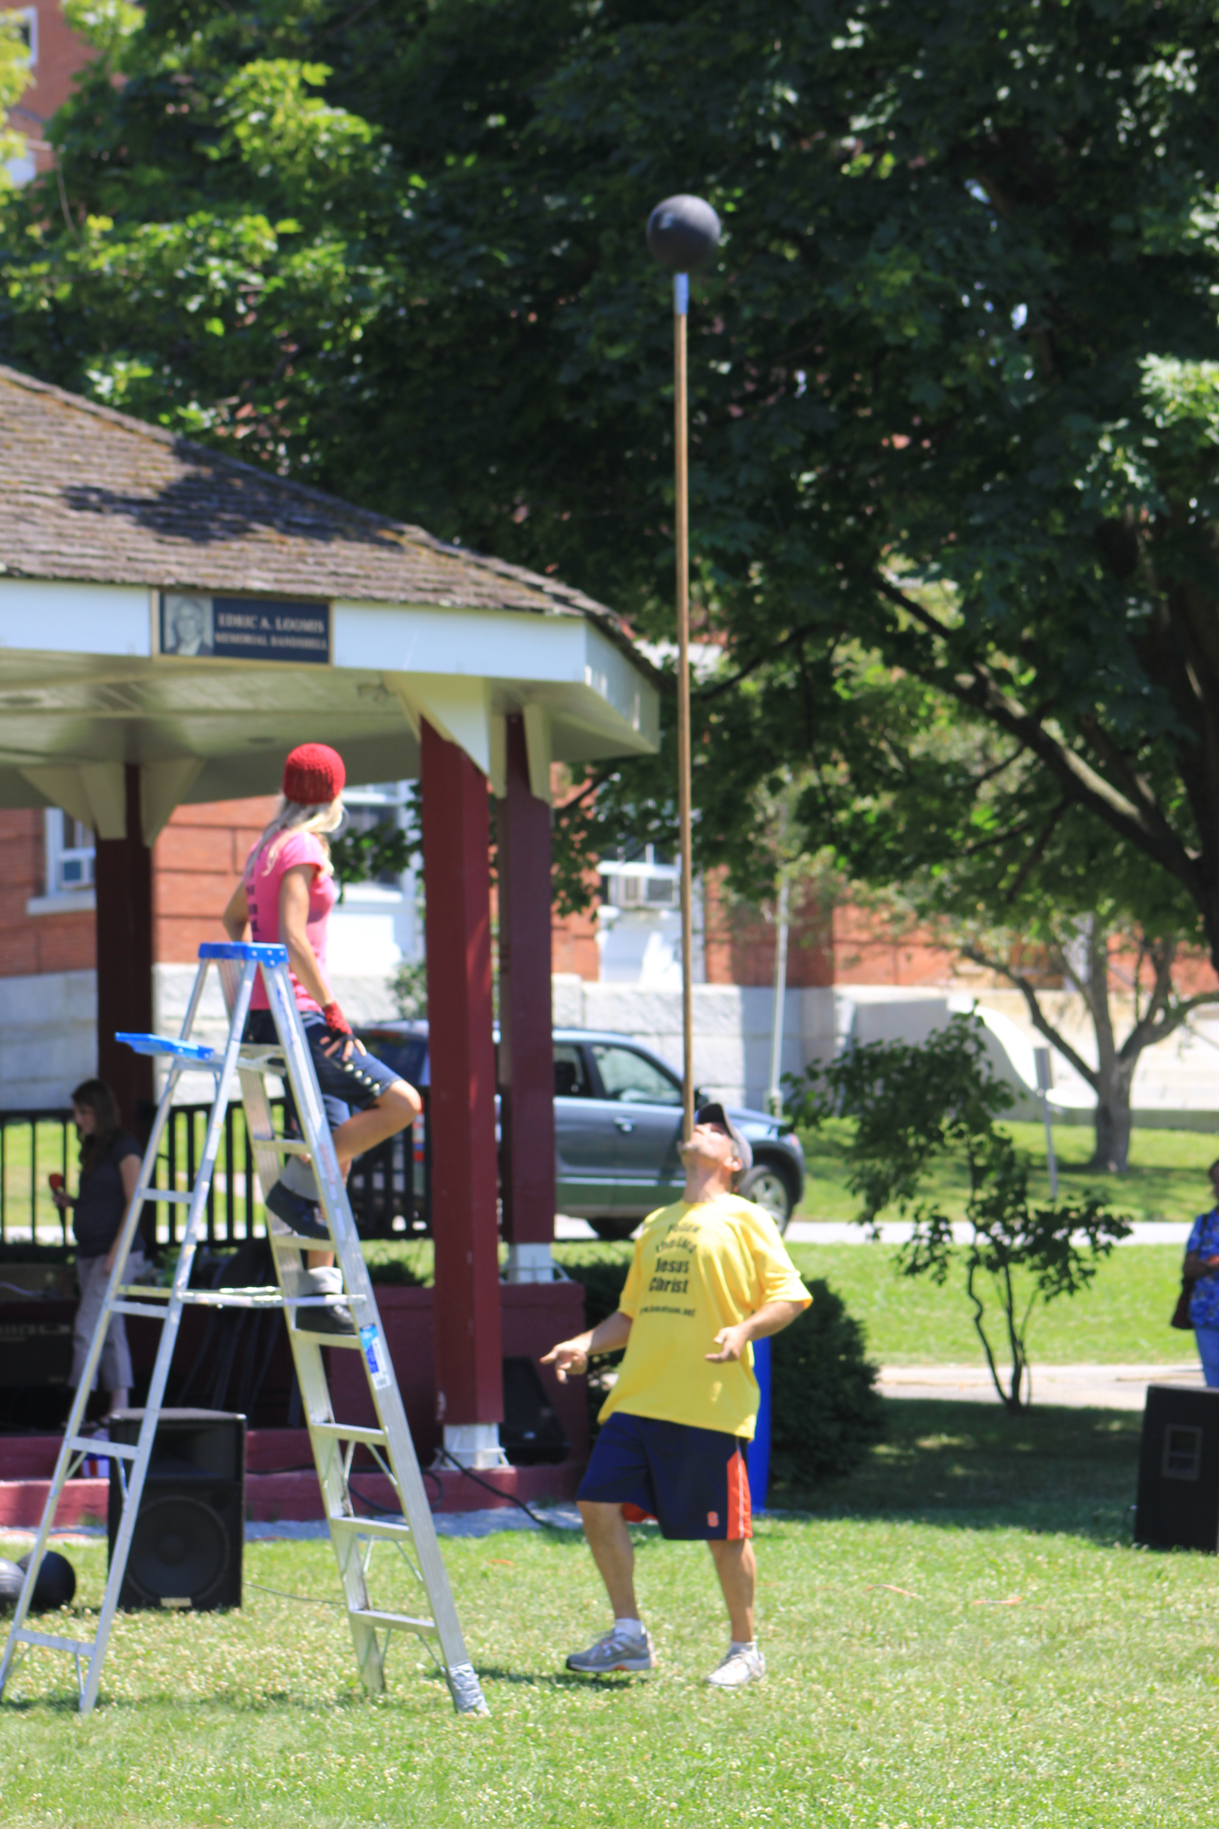
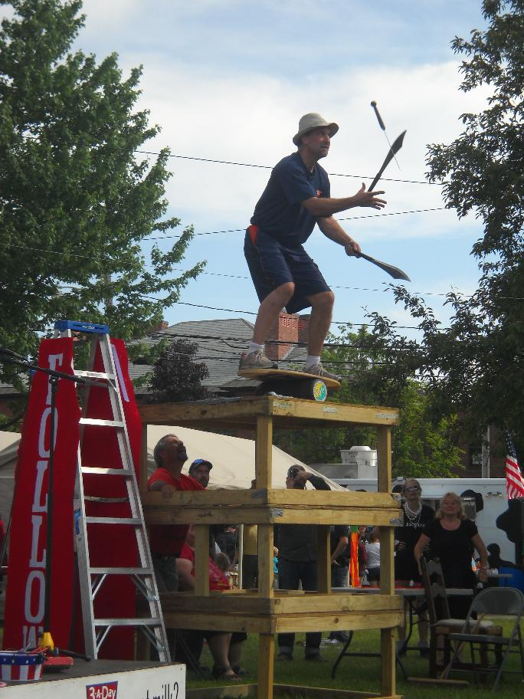
(see www.BasketballFamily.com)
VOLUNTEERS
Ilze spins one, two and five basketballs with volunteers using different props. Two games involving 10-15 volunteers each Music, fun, personal stories. Especially for basketball camps: two ball ballhandling drills with volunteers (talk about the importance of ballhandling).
BOOKING INFO
School assembly (45 min)…$500 Contact for other events.
Several shows at the same location will get a substantial discount. Contact us for other event pricing. Travel expenses might be additional. Set-up: A clean auditorium, gymnasium or multi-purpose room is fine. Can perform on a carpet as well. Can perform in 10x10 feet area (no baskets needed). Please have a PA system/microphone available if possible.
CONTACT Ilze Luneau (315) 345-0613 cell PO Box 812, Enosburg Falls, VT 05450 theluneaus@earthlink.net www.BasketballFamily.com
RECENT PERFORMANCES
The Tonight's Show with Jay Leno ESPN Ellen DeGeneres Show Basketball Hall of Fame Detroit Pistons NBA Charlotte Sting WNBA, NCAA Final Four NBA All-Star Tournament (see more at www.BasketballFamily.com)
RECOMMENDATIONS
“Ilze's presentation was gripping from the first minute to the last. The students were mesmerized by her athletic ability and challenged by her motivational speaking. Students and staff are still talking about it.”
Brent Bowden, Principal at A. A. Cole Elementary School, Constantia, NY
“I would highly recommend The Luneaus for any camp. The Luneaus are not just great entertainment, but also give a valuable message to the campers.” Paul Hewitt, Men’s Basketball Head Coach, Georgia Tech.
"Ilza did a wonderful job again for us this year! This is the second time we brought her in, and she Wowed the crowd! We plan on bringing her back!" Tim Dameron, Game Presentation Manager, 2004 NBA Champion Detroit Pistons (see more at www.BasketballFamily.com)
BACKGROUND
ILZE LUNEAU Originally from Latvia; Varsity Basketball Player-The College of Saint Rose, Albany, NY- Hall of Fame 2007; European Cadet Champion 1991; Performed 2-3 basketball ballhandling shows since the age of 11; MBA in Marketing from SUNY, Albany.
ILIANA, MARIKA and Evangelica LUNEAU Born 2001, 2002 and 2008; dribble 2-4 basketballs each; spin 1-2 balls; sing and dance. New tricks every year.
MATT LUNEAU College basketball coach for last 20 year (last 9 years at Syracuse University) . Currently, teacher and Varsity Boys Basketball Coach at Enosburg High School.

